Scenario: search product in amazon
Step: And the web application URL is launched in a NewWindow - PASS

Step: And the user enters "Apple 17 pro max" into the "search_box" textbox at the "Amazon" page - PASS

Step: User click the "search_button" element at "Amazon" page - PASS
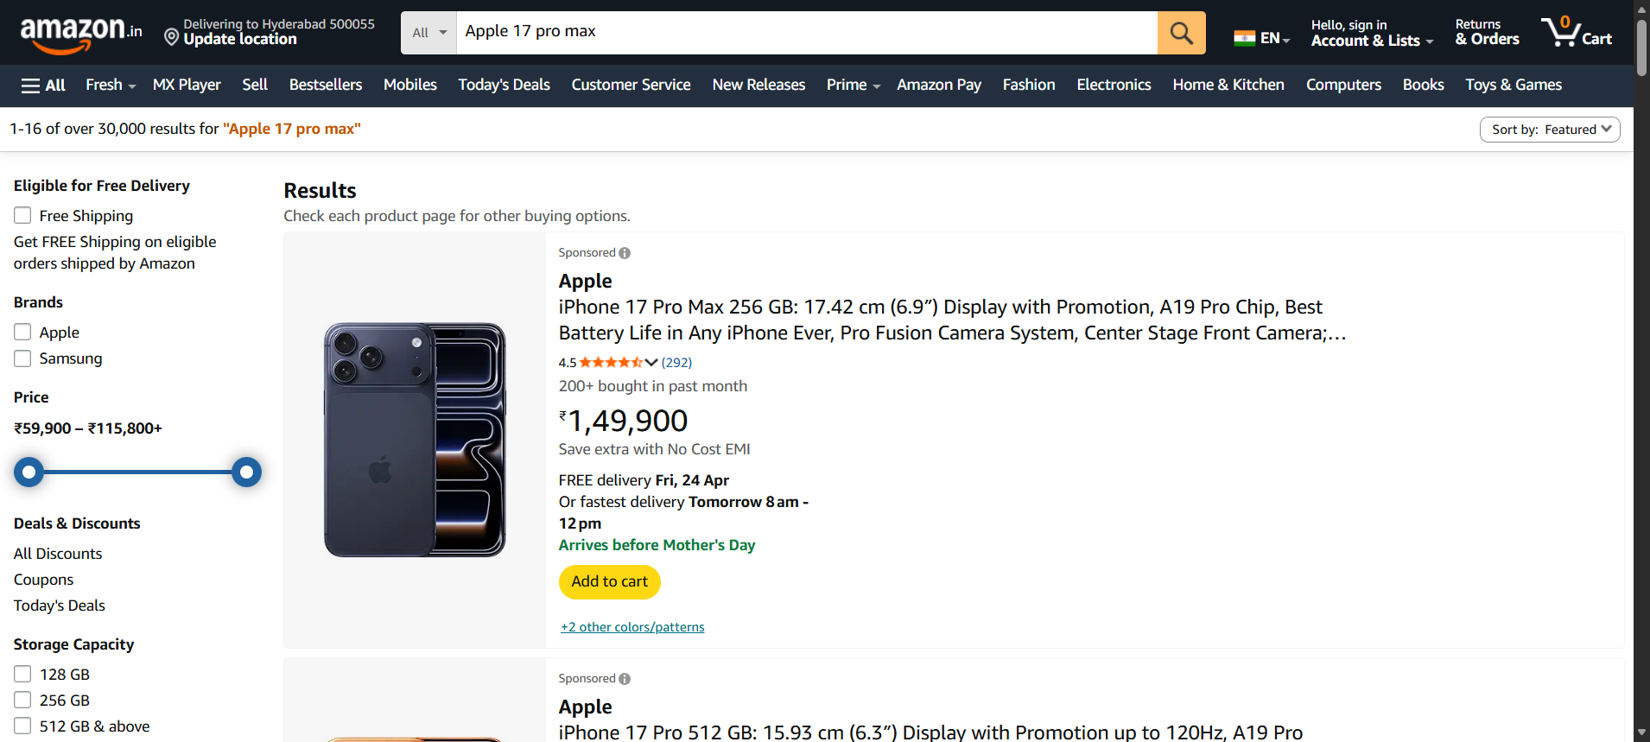
Step: User click the "addtocart" element at "Amazon" page - PASS
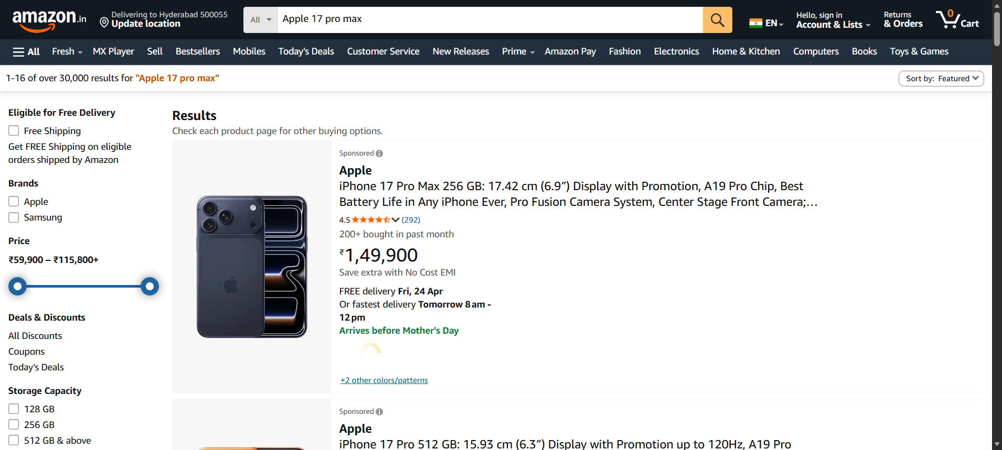
Step: And the user enters "airpods pro 3" into the "search_box" textbox at the "Amazon" page - PASS
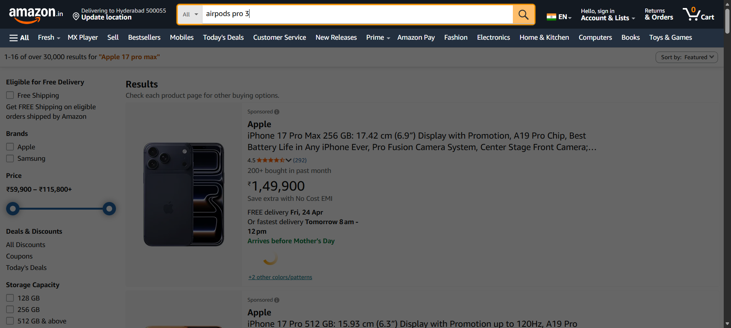
Step: User click the "search_button" element at "Amazon" page - PASS
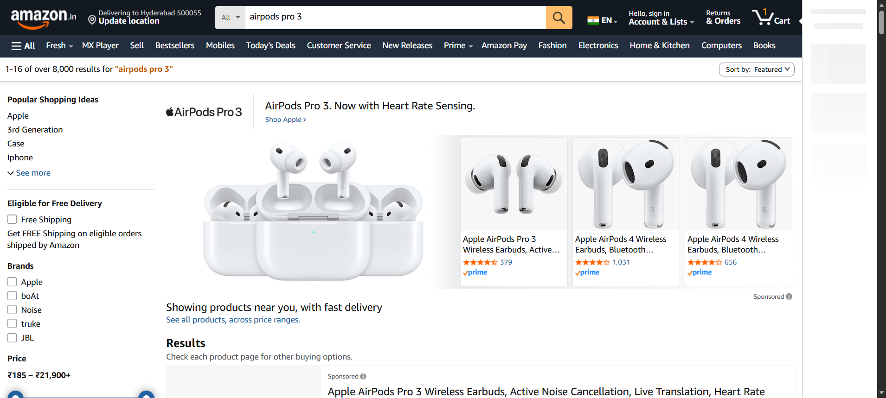
Step: User click the "addtocart" element at "Amazon" page - PASS
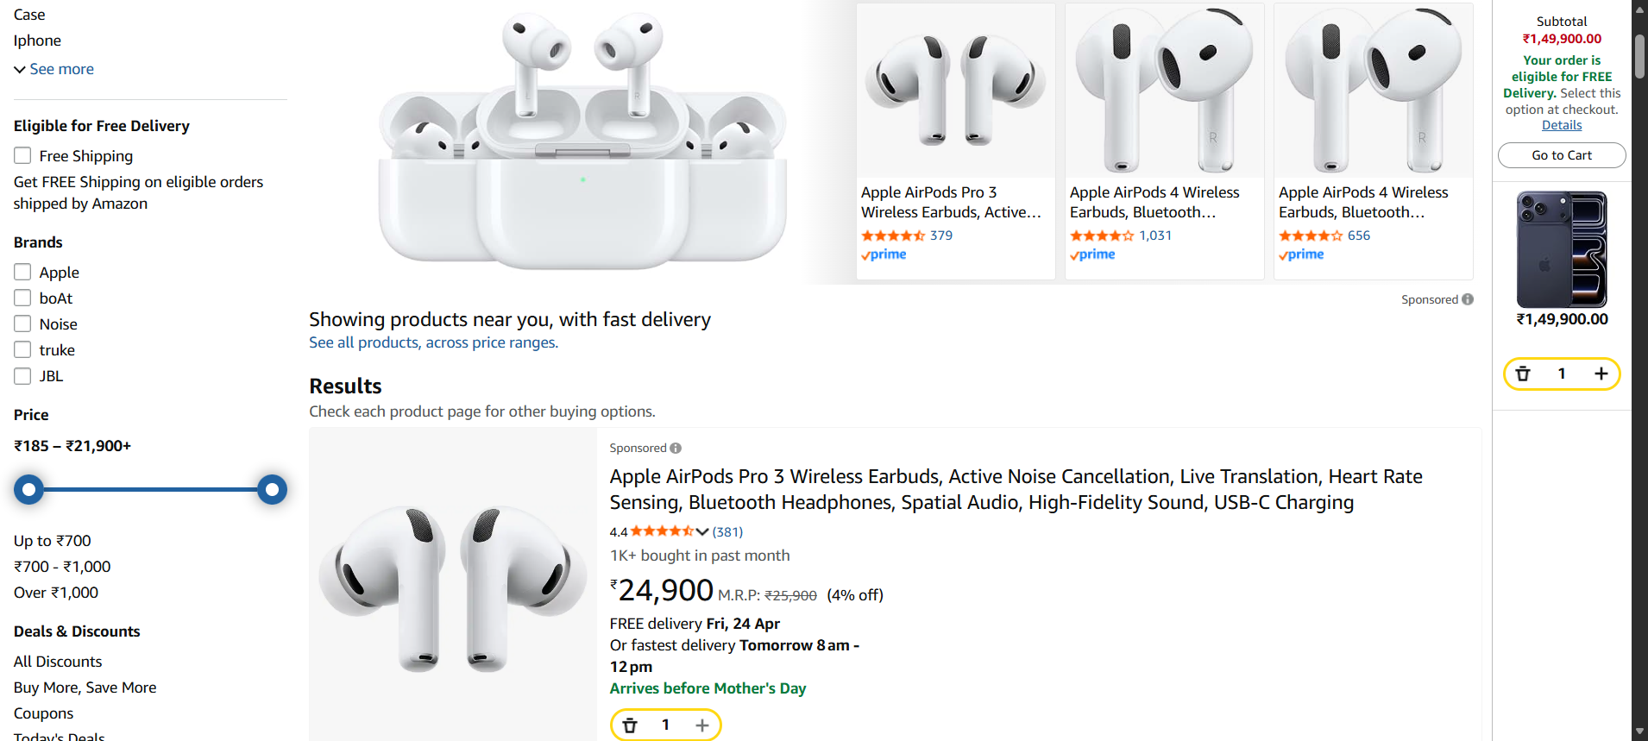
Step: User click the "addtocart_button" element at "Amazon" page - PASS
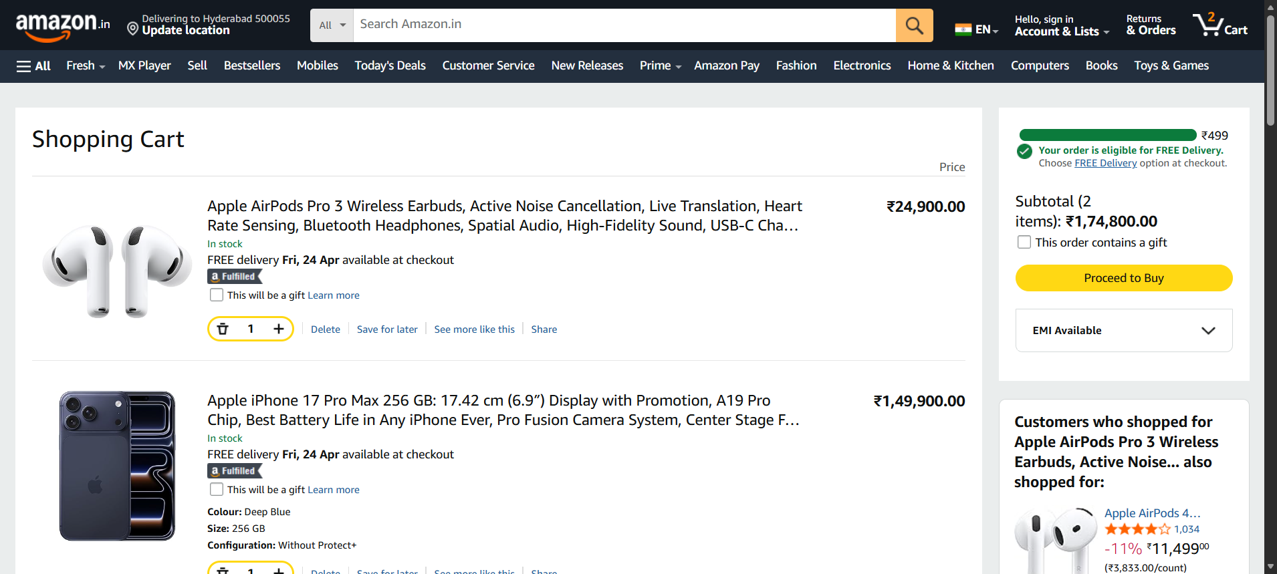
Step: And the user Get the text from"airpods" in "Amazon" page - PASS
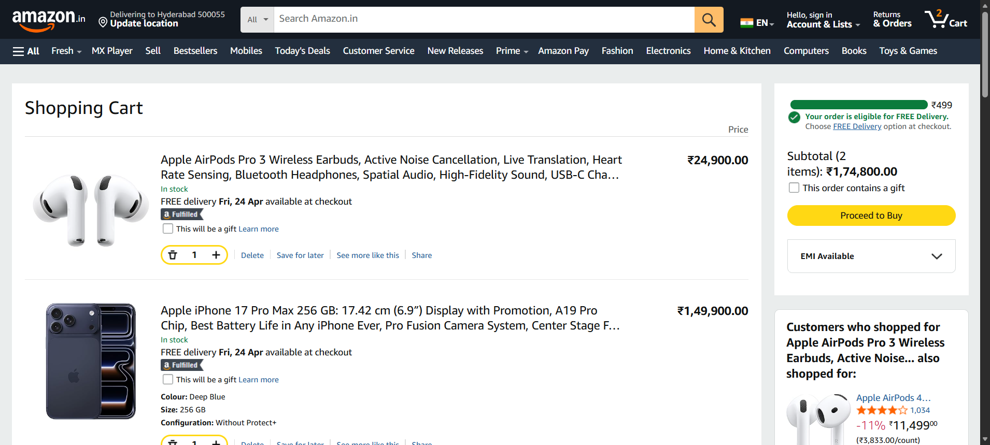
Step: And the user Get the text from"iphone" in "Amazon" page - PASS

Step: And the user waits for "1" seconds - PASS

Execution Summary:
Total Steps: 11
Passed: 11
Failed: 0

